Name: _______________________ ID: _______________________

**Analytical Chemistry II – Quiz (23rd April, 2024)**

1) What is chemiluminescence? What instrumentation do we need to measure chemiluminescence?

Chemiluminescence is produced when a chemical reaction yields an excited species that emits light.

Instrumentation for chemiluminescence detection is simple. The main part is typically photomultiplier tube, while monochromator is not required.

2) The drawing shows interferometer system of a modern FTIR instrument. Explain the principle of its operation. Mention the functions of the elements labeled as *S*1, *S*2, *S*3, *M*1, *M*2, *M*3, *MM*1, *MM*2, *MM*3, *B*1, *B*2, *B*3.

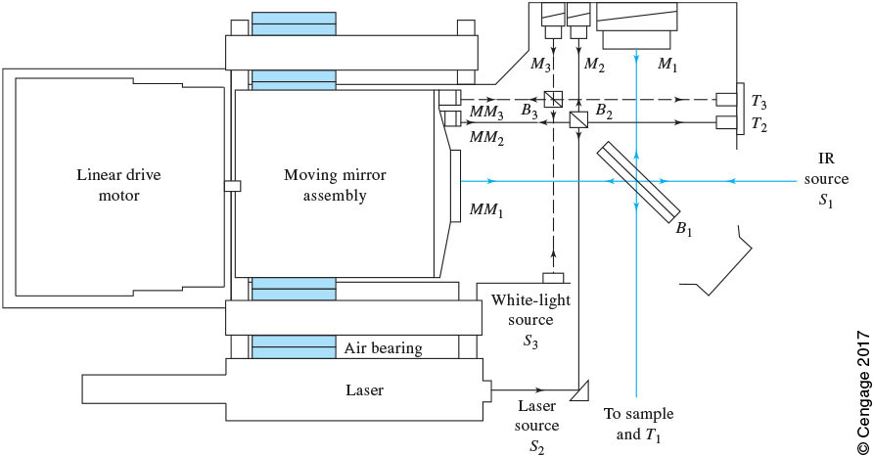

This FTIR instrument takes advantage of three Michelson interferometers to record three interferograms.

During its operation, the moving mirror assembly is moved. The beam from *S*1 is split in *B*1, reflected from fixed mirror *M*1 and movable mirror *MM*1, and the merged beams undergo interference between *B*1 and sample. This way, IR interferogram is created, which can later be converted to IR spectrum. *S*2, *B*2, *M*2, and *MM*2 are used to produce laser-fringe signal, to know the exact position of the moving mirror assembly. *S*3, *B*3, *M*3, and *MM*3 are used to record white light interferogram, to know the position of the moving mirror assembly that corresponds to zero retardation.

*S*1 – IR source used for recording IR interferogram/spectrum of the sample

*S*2 – laser source used to record laser-fringe signal, to know the exact position of the moving mirror assembly

*S*3 – white light source used to record white light interferogram, to know the position of the moving mirror assembly that corresponds to zero retardation

*M*1 – fixed mirror used for recording IR interferogram/spectrum of the sample

*M*2 – fixed mirror used to record laser-fringe signal, to know the exact position of the moving mirror assembly

*M*3 – fixed mirror used to record white light interferogram, to know the position of the moving mirror assembly that corresponds to zero retardation

*MM*1 – movable mirror used for recording IR interferogram/spectrum of the sample

*MM*2 – movable mirror used to record laser-fringe signal, to know the exact position of the moving mirror assembly

*MM*3 – movable mirror used to record white light interferogram, to know the position of the moving mirror assembly that corresponds to zero retardation

*B*1 – beamsplitter used for recording IR interferogram/spectrum of the sample

*B*2 – beamsplitter used to record laser-fringe signal, to know the exact position of the moving mirror assembly

*B*3 – beamsplitter used to record white light interferogram, to know the position of the moving mirror assembly that corresponds to zero retardation